QA Test Suite Execution

1. Install Katalon (need to create an account) [https://www.katalon.com](https://www.katalon.com/)
2. Clone the repository <https://github.com/GZQuispe/QA_Test.git>
3. Open the Project with Katalon
4. Go to Test Suites-> QA_Test

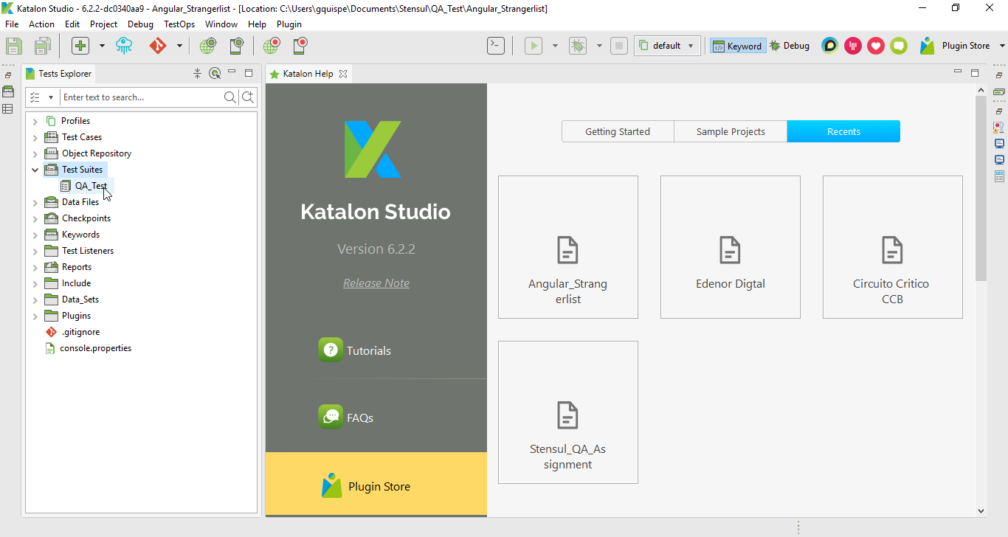

1. Execute the Test Suite

